|  |  |
| --- | --- |
|  |  |



On hovering to the button change the button color



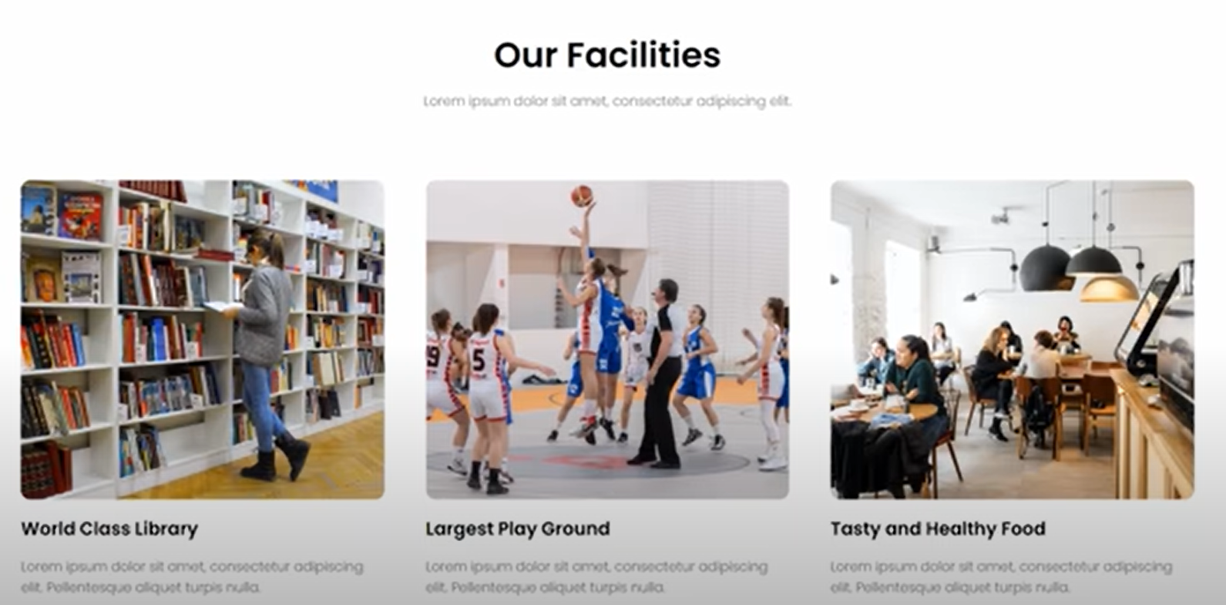



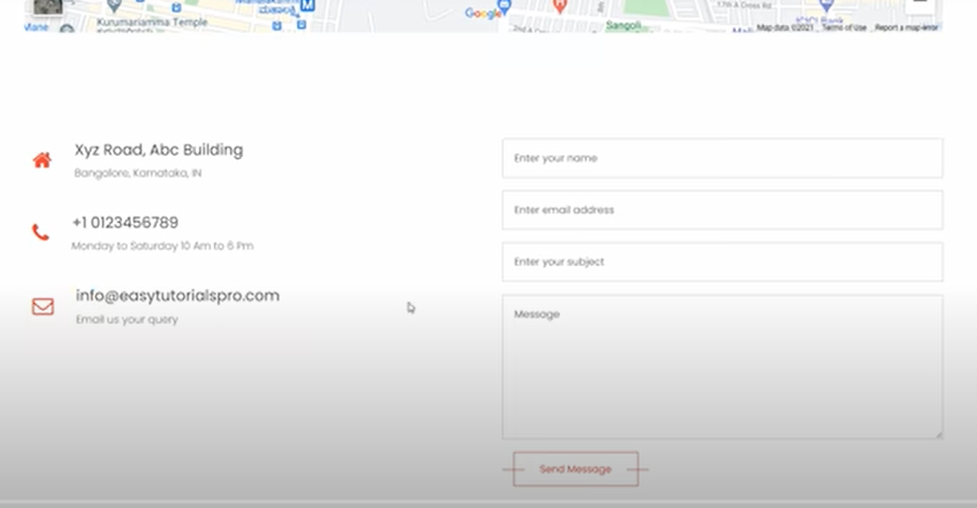



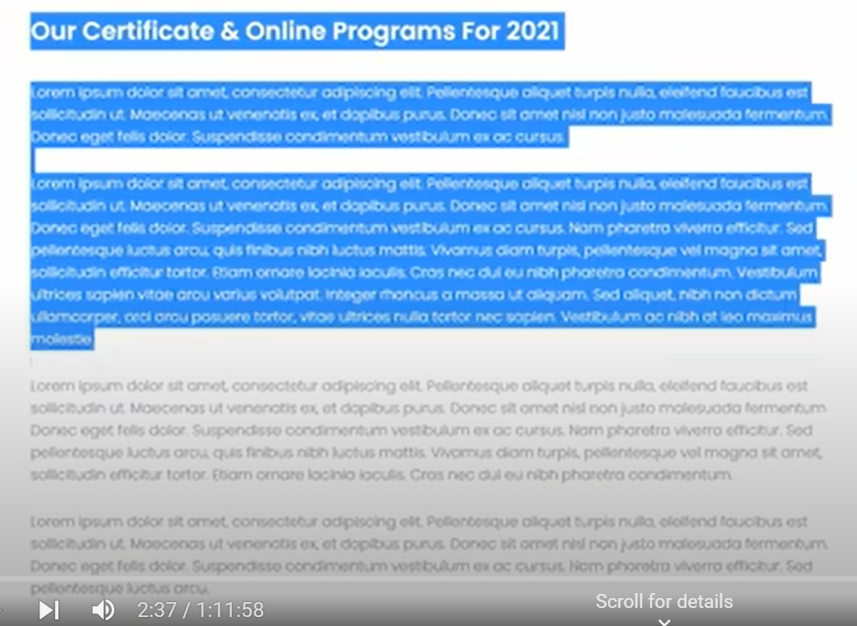

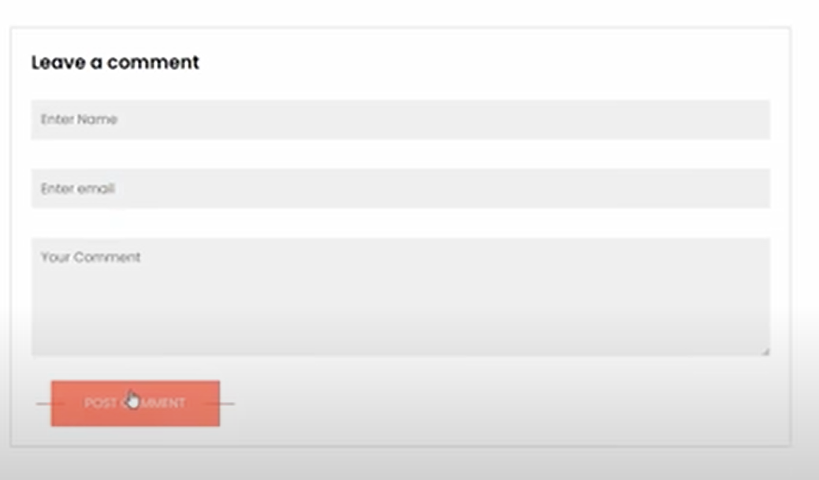

# Code

|  |
| --- |
| Section 🡪background image🡪logo, home, about etc🡪red line 🡪on hover 🡪small screen adjustments |
| <!DOCTYPE html>  <html lang="en">  <head>    <meta charset="UTF-8">    <meta name="viewport" content="width=device-width, initial-scale=1.0">    <title>University Website Design - Easy Tutorial</title>    <link rel="stylesheet" href="style.css">    <link rel="preconnect" href="https://fonts.gstatic.com">    <link href="https://fonts.googleapis.com/css2? family=Poppins:wght@100;200;300;400;600;700&display=swap" rel="stylesheet">    <link rel="stylesheet" href="https://cdnjs.cloudflare.com/ajax/libs/font-awesome/6.6.0/css/all.min.css">  </head>  <body>    <section class="header">      <nav>        <a href="index.html"><img src="images/logo.png" alt=""></a>        <div class="nav-links" id="navLinks">          <i class="fa fa-times" onclick="hideMenu()"></i> <!-- cross icon -->          <ul>            <li><a href="">Home</a></li>            <li><a href="">About</a></li>            <li><a href="">Course</a></li>            <li><a href="">Blog</a></li>            <li><a href="">Contact</a></li>          </ul>        </div>        <i class="fa fa-bars" onclick="showMenu()"></i> <!-- menu icon -->      </nav>        <div class="text-box">        <h1>World's Biggest University</h1>        <p>Making website is now oen of the easiest thing in the world. You just need to learn HTML, CSS, JavaScript          <br/>and you are good to go.</p>        <a href="" class="hero-btn" >Visit us to know more</a>      </div>    </section>    <!-- JavaScript for toogle menu of small screens -->    <script>      var narLinks = document.getElementById("navLinks");      function showMenu(){        navLinks.style.right = "0";      }      function hideMenu(){        navLinks.style.right="-200px";      }    </script>  </body>  </html> |
| *{    margin: 0;    padding: 0;    font-family: 'Poppins', sans-serif;  }  .header{    min-height:100vh;    width: 100%;    background-image: linear-gradient(rgba(4,9,30,0.7), rgba(4,9,30,0.7)),url(images/banner.png);    background-position: center;    background-size: cover;    position: relative;  }  nav{    display: flex;    padding: 2% 6%;    justify-content: space-between;    align-items: center;  }  nav img{    width: 150px;  }  .nav-links{    flex: 1;    text-align: right;  }  .nav-links ul li{    list-style: none;    display: inline-block;    padding: 8px 12px;    position: relative;  }  .nav-links ul li a{    color:#fff;    text-decoration:none;    font-size:13px;  }  .nav-links ul li::after{    content: '';    width: 0%;    height: 2px;    background: #f44336;    display: block;    margin:auto;    transition: 0.5s;  }  .nav-links ul li:hover::after{    width: 100%;  }  .text-box{    width: 90%;    color: #fff;    position: absolute;    top: 50%;    left: 50%;    transform: translate(-50%, -50%); /* to come to center of the screen */    text-align: center;  }  .text-box h1{    font-size: 62px;  }  .text-box p{    margin: 10px 0 40px;    font-size: 14px;    color: #fff;  }  .hero-btn{    display: inline-block;    text-decoration: none;    color:#fff;    border:1px solid #fff;    padding:12px;    font-size: 13px;    background-color: transparent;    position: relative;    cursor: pointer;  }  .hero-btn:hover{    border: 1px solid #f44336;    background: #f44336;    transition: 1s;  }  nav .fa{ /* hiding icons */    display: none;  }  @media(max-width: 700px){    .text-box h1{      font-size: 20px;    }    .nav-links ul li{      display: block;    }    .nav-links{      position: absolute;      background-color: #f44336;      height: 100vh;      width: 200px;      top: 0;      right: -200px;      text-align: left;      z-index: 2;    }    nav .fa{      display: block;      color: #fff;      margin: 10px;      font-size: 22px;      cursor: pointer;    }    .nav-links ul{      padding: 30px;    }  } |